

**MSC CYBER SECURITY & PEN TESTING**

**CST4530**

**SECURITY SOLUTIONS & APPLICATIONS**

**LAB C2 NETWORK ACCESS CONTROL**

**JOHN ODI ETTA**

**M00783479**

CST 4530 lab5 wk 9

**TASK 1**

A 2811 router is added and renamed R3 to the existing network. Similarly, Server 1 is directly connected to R3 using the FastEthernet 0/0 interface.

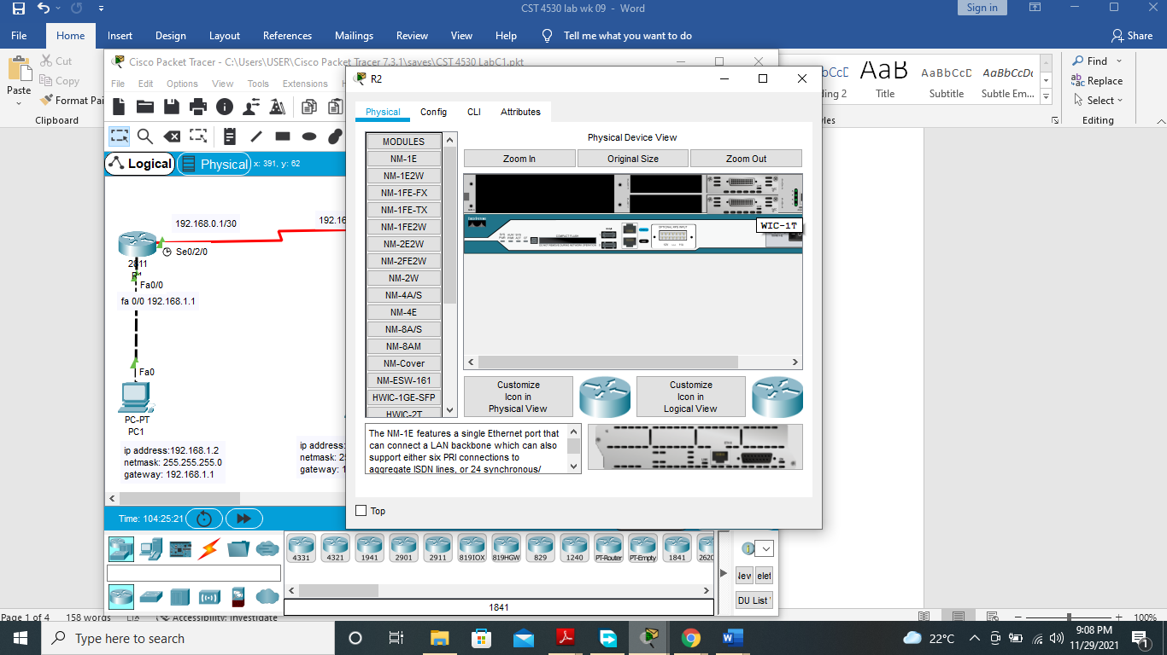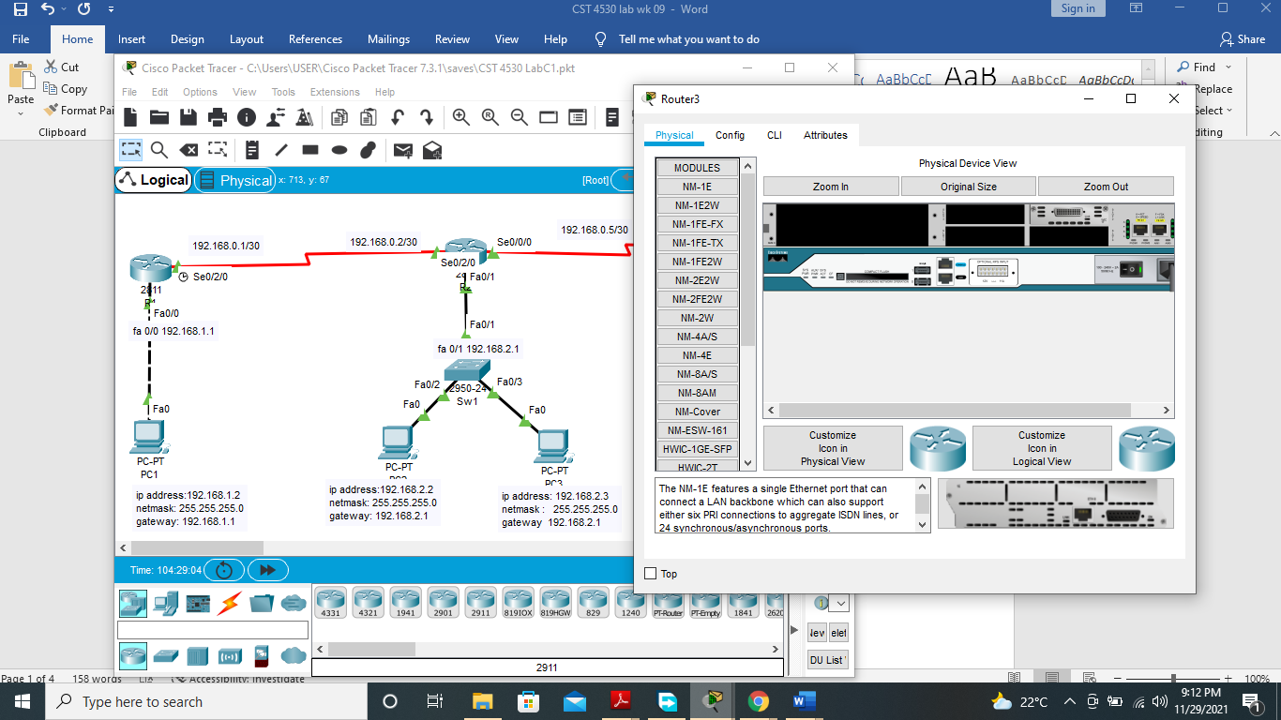

A WIC-1T WAN module was added to R3. Another WAN module was also added to R2. And configured using 192.168.0.5/30 on R2 and 192.168.0.6/30 on R3 respectively. Server 1 was also assigned the IP address 192.168.3.2, sub netmask 255.255.255.0, and gateway 192.168.3.1.

CONNECTIVITY TEST.

Ping server 1 from pc 1.



The ping request from pc1 to server 1 is successful.

Traceroute pc1 to server 1.

The network route is shown between pc 1 and server 1.



**TASK2** **Standard Access Control Lists**

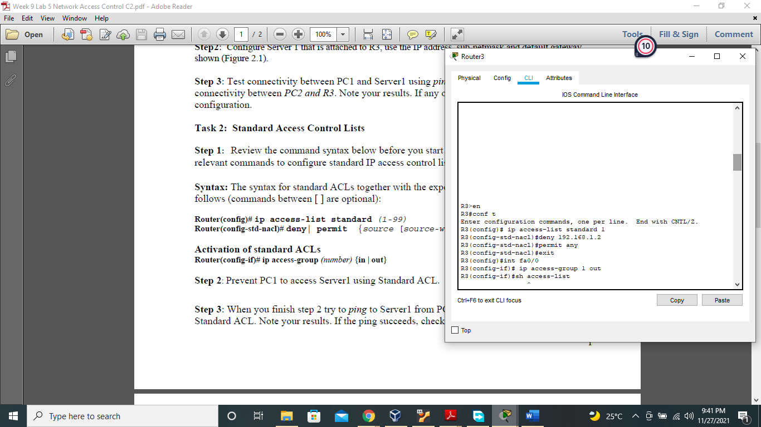

The IP address of pc1 was prevented from accessing R3 using the standard access-list 1.

Access-list was activated using the “IP access-group 1 out” command.

Ping from Pc1 to Server 1: Using standard ACL

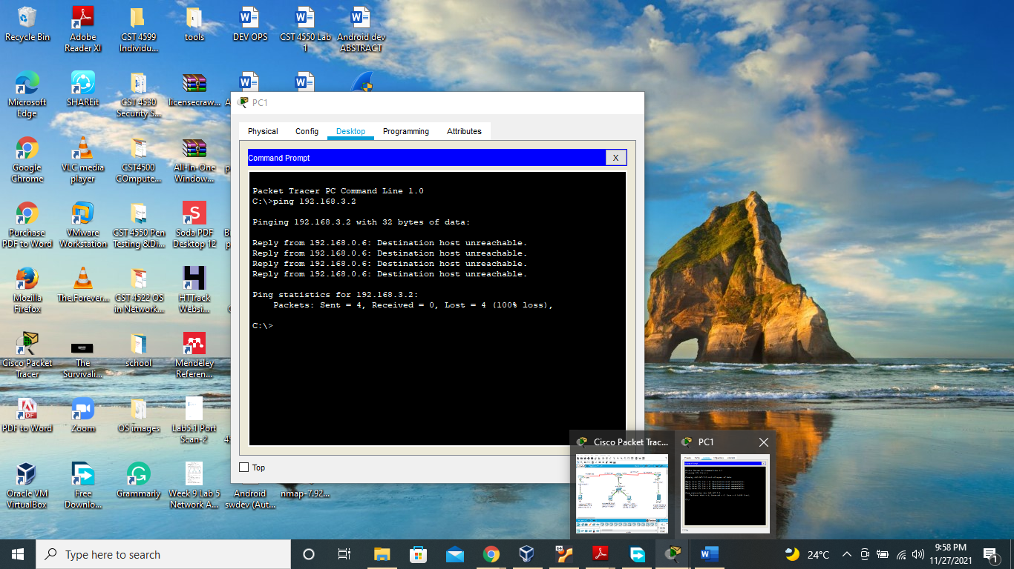

Ping status from pc 1 to server failed due to ACL in place restricting access from Pc1 to Server.

*Ping* from R1 to Server1. The ping should succeed, if not, check your configurations.

Explain why the ping successfully completed?

R1 pinging server 1

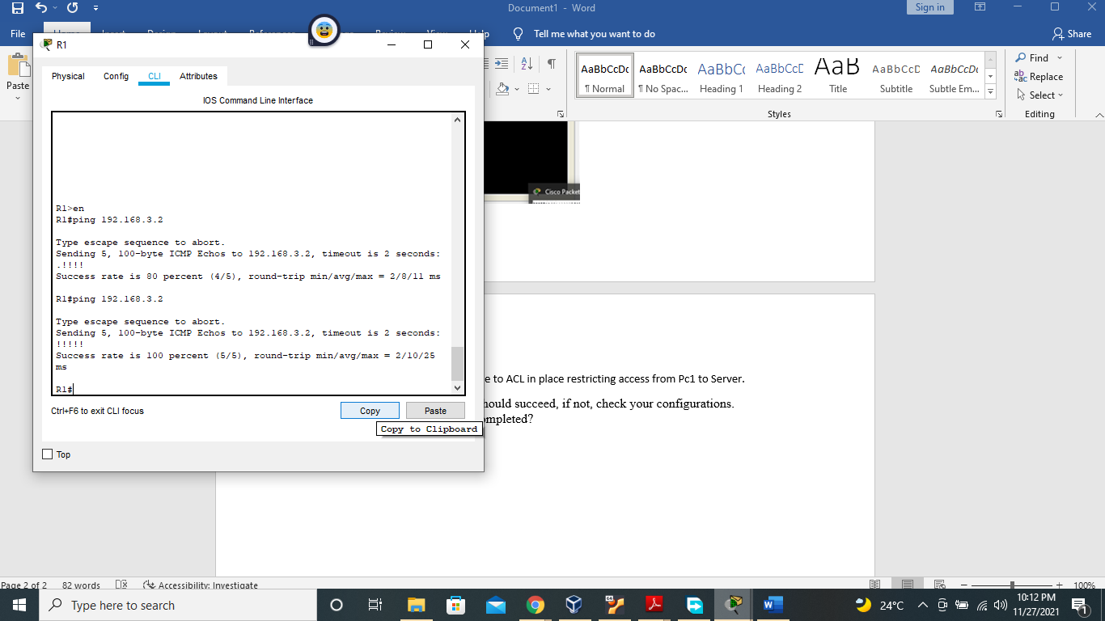

The ping from R1 to Server 1 is successful because a standard ACL was implemented only on pc 1, denying only PC1, and permitting all other connections on the network.

**Task 3: Extended Access Control Lists**

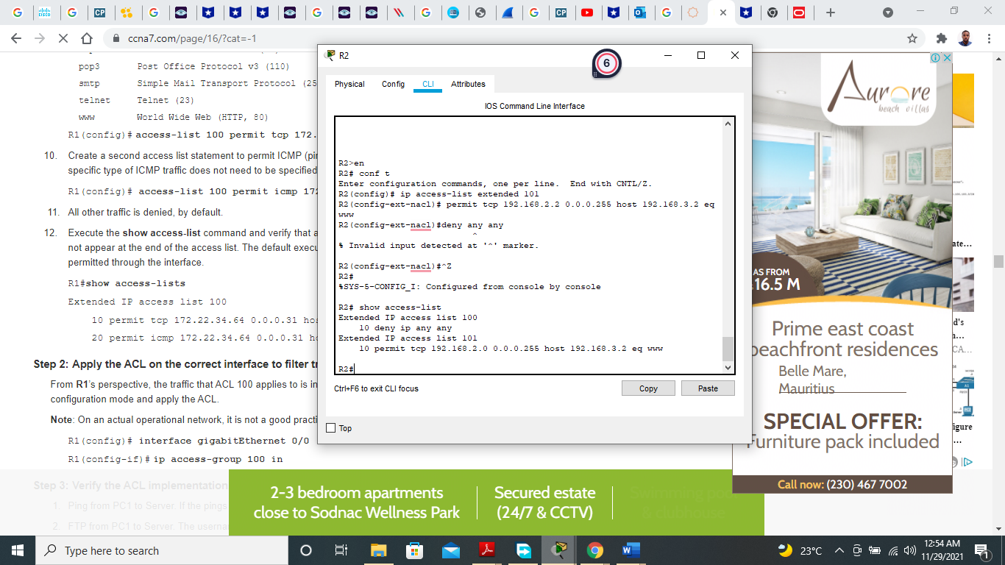

Because of the ACLs activated, only pc 2 is allowed access to server 1. All other communication to sever 1 is blocked by the implicit denial of communication imposed by ACL.

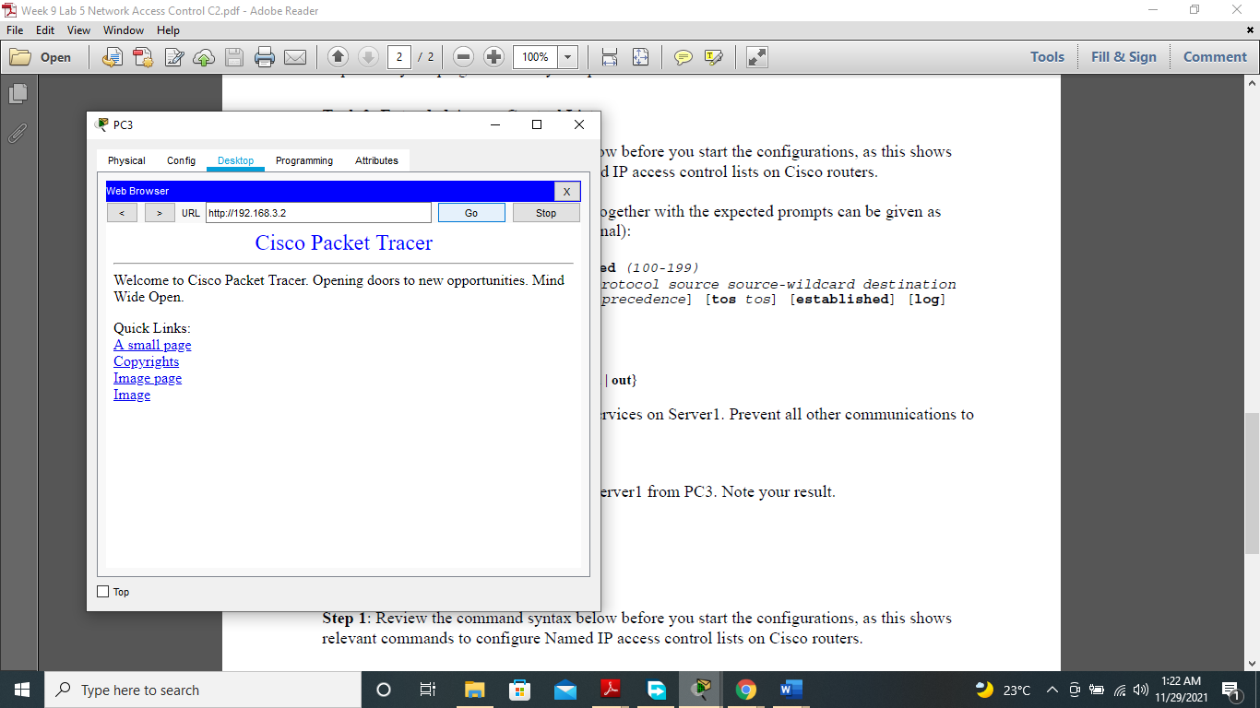

**Only Server1should be allowed to telnet R3 using Named ACL. Record your steps.**

R3(config)#ip access-list extended notelnet

R3(config-ext-nacl)#exit

R3(config)#line?

line

R3(config)#line vty?

vty

R3(config)#line vty 0 4

R3(config-line)# access-class telnet in

R3(config-line)#^Z

R3#

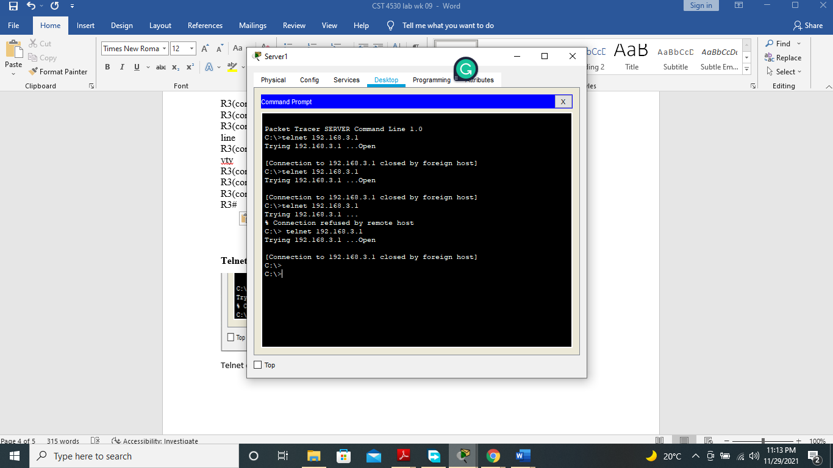

**Telnet R3 from Pc2**

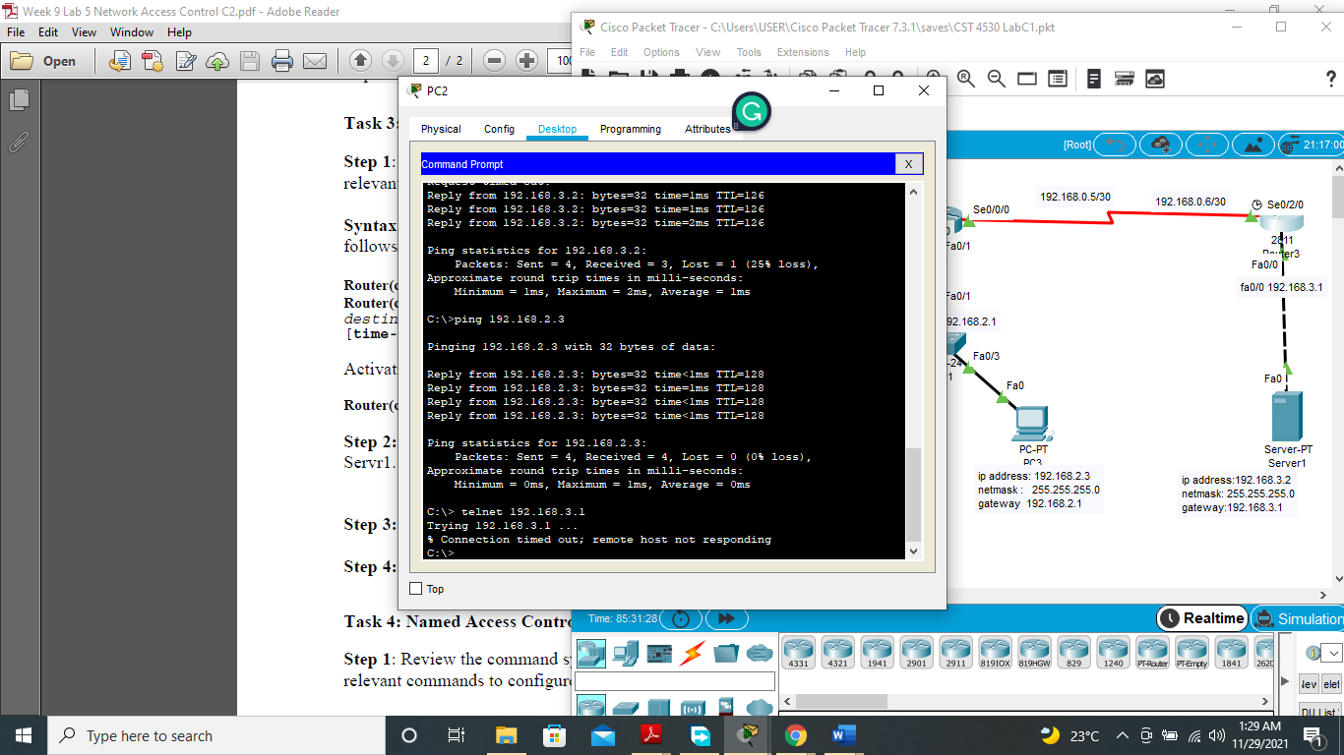

Telnet connection from Pc2 to R3 timed out.

**Step 3:** After step 2 of task 4 try to telnet R3 from PC2. Record your results

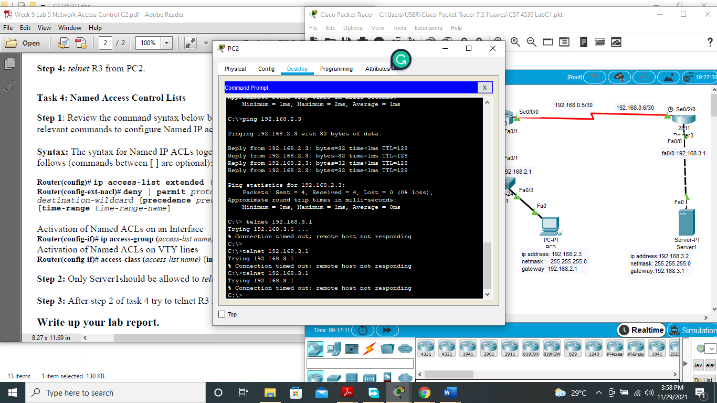

Pc 2 is unable to telnet R3.